ALDBURY PARISH COUNCIL WARDENS UPDATE: OCTOBER 2023

AREA | ALLOTMENTS & MILLENNIUM ORCHARD
TO CHECK | Fencing & gates, benches, trees, hedges & shrubs, grass height, signs, footpaths, housekeeping, ground conditions
INSPECTION DATES | 29/09, 06/010,13/10, 20/10, 27/10
ISSUES TO REPORT | - No defects were noticed on fences, gates, and benches.  - Grass height is meeting the mowing specification.  - APC are in the process of obtaining quotes from two tree surgeons to carry out corrective works as per tree survey recommendations.  - Footpath waymarkers were in place. No obstructions evident.  - Benches were seen in fair condition.  - Allotment hedge running parallel with Trooper Road is overgrown but is not inhibiting access (Photo 1). APC may wish to arrange cutting next year.

AREA | PLAYGROUNDS
TO CHECK | Equipment, Safety Information, Fencing & Gates, Benches, Trees, Grass height, General ground conditions, Empty litter bin.
INSPECTION DATES | 29/09, 06/010,13/10, 20/10, 27/10  Tring Station 06/10
ISSUES TO REPORT | - Grass height meets the mowing specification.  - Litter bin was emptied on the 13th of October.  - Essential user information signs were in place. All were legible.  - Fences and gates remain in fair condition.  - Wildwood have successfully replaced an unsteady climbing frame post at Tring Station playground (Photo 2). Post is now sturdy.  - Gushing water was seen coming from the Iron Room. Possible burst water pipe (Photo 3). Clerk has informed TSRA.  - Brambles and nettles growing through the Aldbury Playground fence have been cut back.  - Concrete surface at the rear of the Iron Room is beginning to break up (Photo 4).  Outstanding items  - Overgrown hedge(s) at Tring Station playground require cutting (Photo 5). Clerk liaising with contractor.

AREA | RECREATION GROUND
TO CHECK | Tennis court, Basketball area, Pavilion, Fencing, Benches/seats, Bollards, Trees & vegetation, Grass height, car park, Litter & dog waste bins, Footpaths.
INSPECTION DATES | 29/09, 06/010,13/10, 20/10, 27/10
ISSUES TO REPORT | - Grass height is meeting the mowing specification. Last cut took place on the 27th of October.  - Weekly litter picks were carried out.  - The Tennis court surface was observed in good condition.  - Car park hedge is overgrown. A cut has been scheduled.  Outstanding items  - Essential tree works as advised in the recent tree survey report.

AREA | VILLAGE GREEN(S) & POND
TO CHECK | Benches, Trees, Pond, Grass height, Stocks, Litter Bins, Notice board.
DATES | 29/09, 06/010,13/10, 20/10, 27/10
ISSUES TO REPORT | - Grass height is meeting the mowing specification. Recent turfing has proved successful around the pond enhancing appearance.  - Weekly litter picks were conducted.  - A wooden post recently knocked over by a motor vehicle, has been reinstated - village green nearest the post office (Photo 6)..  Outstanding items  - Pruning of both mature trees as per tree survey recommendations.
AREA | HIGHWAY’S, PUBLIC FOOTPATHS & DITCHES
TO CHECK | Surfaces, Pedestrian routes, Signage, Drainage, Grit bins, Litter, Street lamps, Bollards, kissing gates, Notice board (Tring Station)
DATES | 29/09, 06/010,13/10, 20/10, 27/10  (Streetlamps) 12/10
ISSUES TO REPORT | - All streetlamps were seen in working order on the 12th of October.  - Litter picking was conducted in Stocks Road (to the walled garden), New Ground Road (to the canal bridge), Station Road (to Church Farm) and Tring Station (GUC Bridge to station drop-off entrance).  - Uneven and potholed road surface by the Beechwood Drive/Toms Hill junction has been repaired by HCC. Ref No: 401003701638 (Photo 7).  - All blocked drains in Aldbury Village were cleared by HCC Highways during w/c 23rd of October (Photo 8).  - Two faded SLOW road markings on Toms Hill were reported to HCC. Ref No’s 401003740702 and 401003740705 (Photo 9 & 10).  - New signs promoting a new local enterprise ‘Church Farm Café’ on display by FP No: 50 kissing gate (Photo 11) and the main entrance to Church Farm.  - In association with recent drainage works, HCC have cleared circa 25 metres of an open ditch/drain (south of Stonycroft) to facilitate water flow from the pond (Photo 12). Further clearance is still needed. APC may wish to alert the riparian landowner(s), who are responsible for ensuring water flows without obstruction i.e.. Vegetation, fallen branches.  Outstanding items  - The salt/grit bin at the top of Malting Lane is virtually empty and needs replenishing. Clerk is waiting for grit delivery.  - The following HCC Highway work remains outstanding.  - Faded markings by the Stonycroft junction (Ref No: 401002519044).  - Uneven road surface by the pond. Ref No:401003511836  - Removal of graffiti from a road sign by the Beggars Lane / Station Road Junction. Ref No: 401003475040. HCC report work has been scheduled..  - Flood problem by the Tring Station railway bridge (Ref No: 401003099775). HCC Drainage Team are aiming for repair works in the 2023/24 budget year (Ref No: 401003156048). Flooding formed on 29th of October making conditions awkward for pedestrians, cyclists, and motorists (Photo 13)..  - Blocked storm drains/gullies in Tring Station (Station Road). Ref No: 401003164554
PHOTOGRAPHS
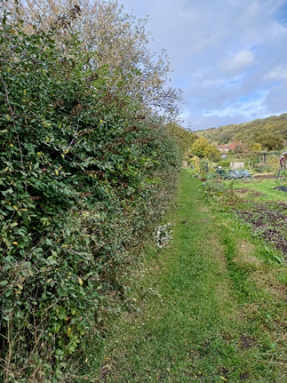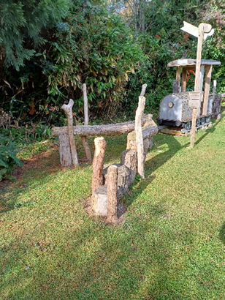
2
1
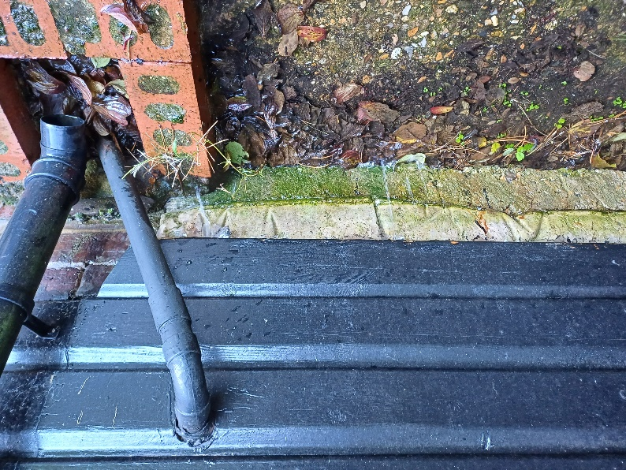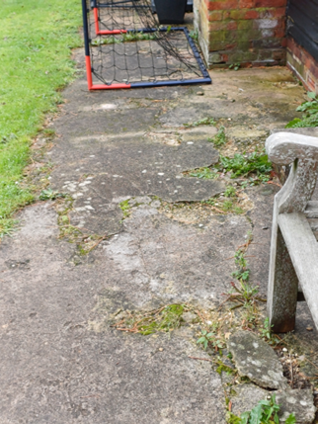
3
4
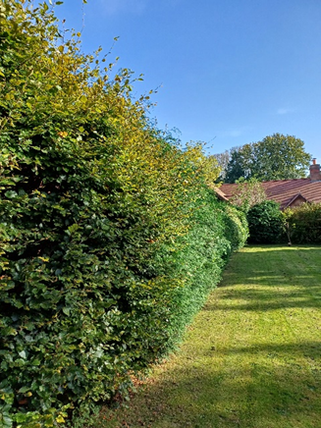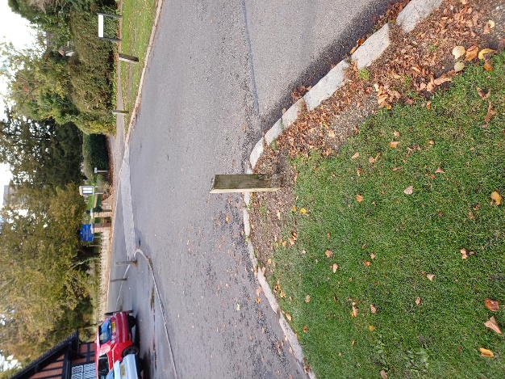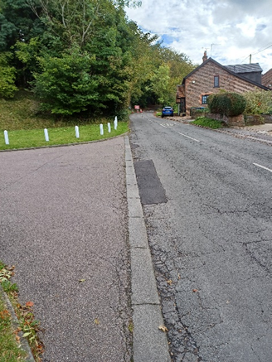
7
5
6
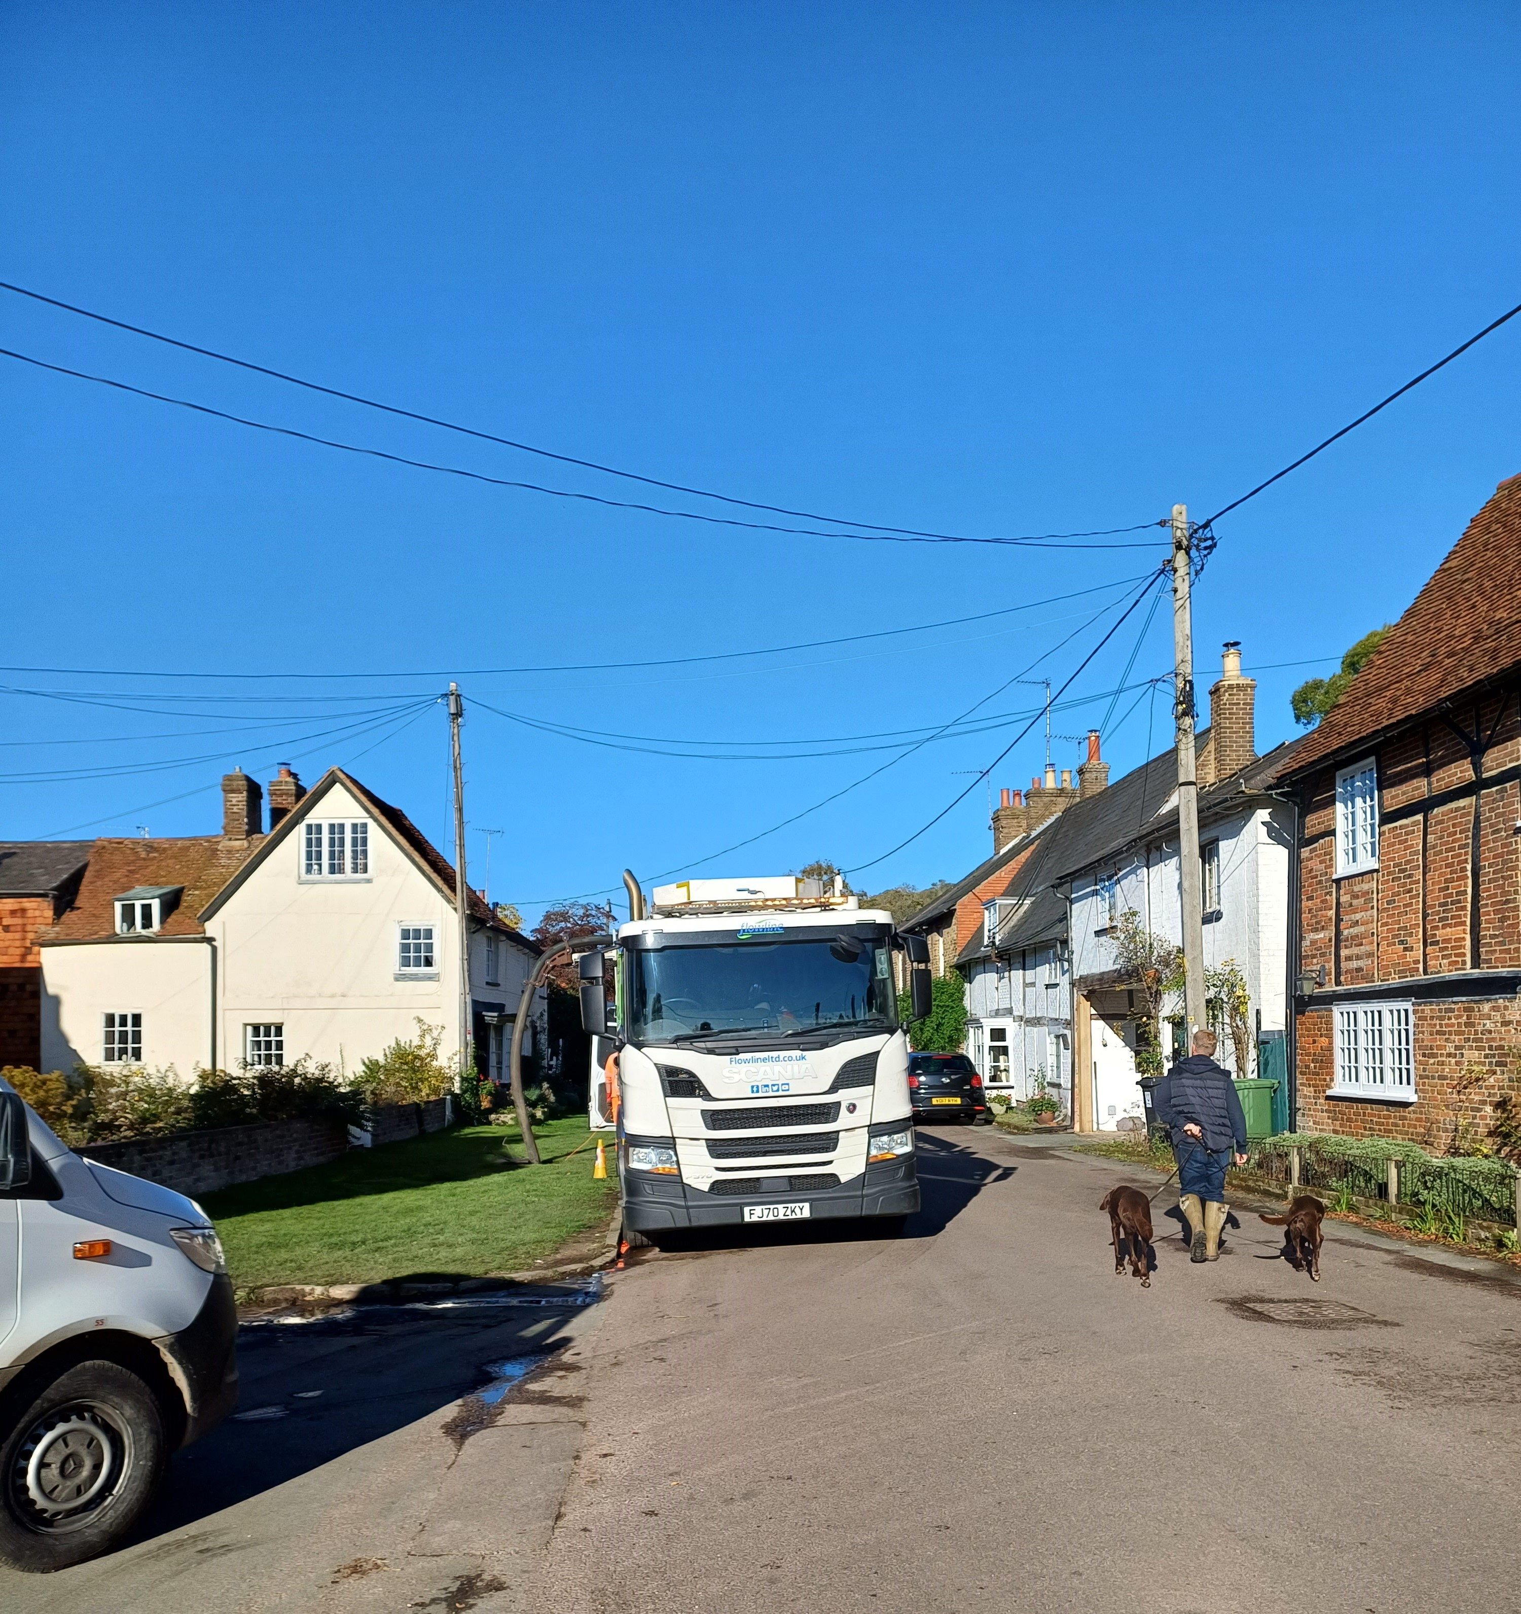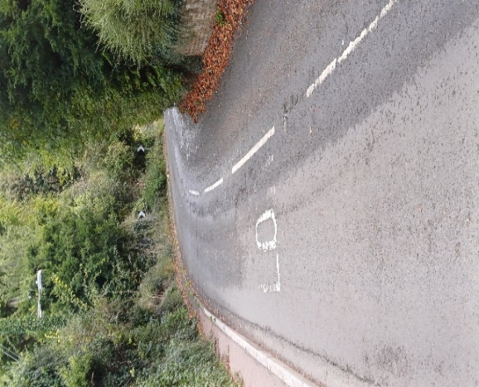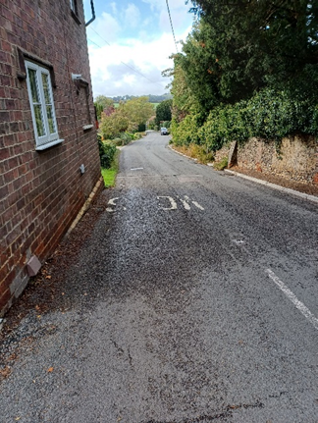
10
9
8

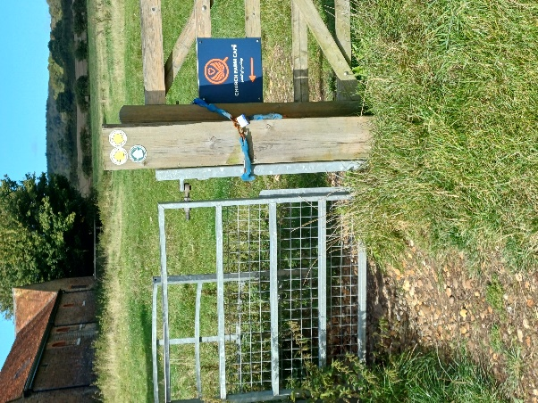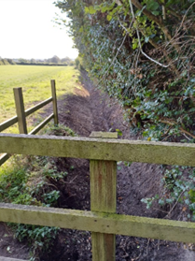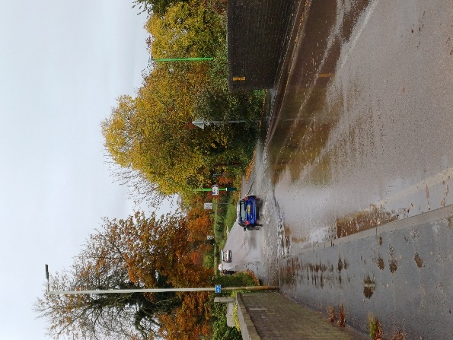
13
12
11

